

Tribhuvan University Institute of Science and Technology

Seminar Report
On
“Movie Recommendation System Using Collaborative, Content-Based and Probabilistic Approaches”
Submitted to
Central Department of Computer Science and Information Technology Tribhuvan University, Kritipur
Kathmandu, Nepal

In partial fulfillment of the requirement for Master’s Degree in Information Technology (MIT)
2nd Semester

Submitted By Melina Giri
Roll No: 8125018
April, 2026



Tribhuvan University Institute of Science and Technology

SUPERVISOR’S RECOMMENDATION

I hereby recommend that this Seminar report, prepared under my supervision by Melina Giri entitled "Movie Recommendation System Using Collaborative, Content-Based and Probabilistic Approaches" be accepted as fulfillment in partial requirement for the degree of Master's in Information Technology. To the best of my knowledge, this is an original work in computer science.

…………………………………… Supervisor
Asst. Prof. Mr. Jagdish Bhatta
Central Department of Computer Science and Information Technology

LETTER OF APPROVAL
This is to certify that the seminar report prepared by Ms. Melina Giri entitled "Movie Recommendation System Using Collaborative, Content-Based and Probabilistic Approaches" in partial fulfillment of the requirements for the degree of Masters in Information Technology has been well studied. In our opinion, it is satisfactory in the scope and quality as a project for the required degree.

Evaluation Committee

.……………………………. .…………………………….
Asst. Prof. Sarbin Sayami Asst. Prof. Mr. Jagdish Bhatta (H.O.D) (Supervisor)

Central Department of Computer Science and Information Technology
Central Department of Computer Science and Information Technology

...........................…
(Internal)

ACKNOWLEDGEMENT
The success and final outcome of this report required a lot of guidance and assistance from many people and I am very fortunate to have got this all along the completion. I am very glad to express my deepest sense of gratitude and sincere thanks to my highly respected and esteemed supervisor Asst. Prof. Mr. Jagdish Bhatta, Central Department of Computer Science and Information Technology for his valuable supervision, guidance, encouragement, and support for completing this paper.
I am also thankful to Asst. Prof. Sarbin Sayami, HOD of Central Department of Computer Science and Information Technology for his constant support throughout the period. Furthermore, with immense pleasure, I submit my deepest gratitude to the Department of Computer Science and Information Technology, Tribhuvan University, and all the faculty members of CDCSIT for providing the platform to explore the knowledge of interest.
I would also like to acknowledge the authors and contributors of the MovieLens Dataset available from GroupLens Research. Their publicly available dataset was fundamental for completing this research experiment.
At the end I would like to express my sincere thanks to all my friends and others who helped me directly or indirectly.

Melina Giri (8125018)
Central Department of Computer Science and Information Technology

ABSTRACT
Recommendation systems have become essential for personalized content delivery in modern digital platforms such as streaming services, e-commerce, and social media. This research implements a Movie Recommendation System Using Collaborative, Content-Based and Probabilistic Approaches with the MovieLens dataset (GroupLens Research). The dataset is preprocessed through normalization, matrix construction, and similarity computation. Collaborative filtering predicts user preferences by identifying similar users using cosine similarity, while content-based filtering recommends movies based on feature similarity such as genres. Model evaluation includes RMSE (Root Mean Square Error) and a similarity score distribution, which highlight how well the model differentiates user preferences. The results show that collaborative filtering performs effectively for users with sufficient rating history, whereas content-based filtering addresses the cold-start problem for new users.

Keywords: Recommendation System, Collaborative Filtering, Content-Based Filtering, Cosine Similarity, MovieLens Dataset, Machine Learning, RMSE, Hybrid Recommender.

Table of Contents

SUPERVISOR’S RECOMMENDATION i
LETTER OF APPROVAL ii
ACKNOWLEDGEMENT iii
ABSTRACT iv
Table of Contents v
LIST OF FIGURES vii
LIST OF TABLES viii
LIST OF ABBREVIATIONS ix
CHAPTER 1: INTRODUCTION 1
  - Introduction 1
  - Problem Statement 2
  - Objectives 2
CHAPTER 2: PREVIOUS WORKS, DISCUSSIONS AND FINDINGS 3
  - Background Study 3
  - Literature Review 3
  - Methodology 5
    - Flowchart 5
    - Dataset Description 5
    - Algorithm Description 7
  - Implementation 8
    - Implementation Tools 8
    - Implementation Details 8
  - Result Analysis 9
    - Quantitative Analysis 9
    - Qualitative Analysis (Actual System Output) 12
CHAPTER 3: CONCLUSION 15
  - Conclusion 15
  - Future Recommendation 15
References 17
Appendix 18
  - Main Interface Code 18
  - Loading Dataset and Building User–Movie Matrix 18
  - Collaborative Filtering and Prediction 19
  - Naive Bayes Recommendation Code 20
  - Dataset Preview Logic 21

LIST OF FIGURES
Figure 1 : Overview of Movie Recommendation Work flow 5
Figure 2 : RMSE vs Number of Neighbors (k) 9
Figure 3 : Similarity Score Distribution 10
Figure 4 : Confusion Matrix for Rating Prediction 11
Figure 5 : RMSE Comparison of Different Methods 12
Figure 6 : Sample Recommendations Output from the System 12

LIST OF TABLES
Table 1 : Accuracy/ RSME Summary 11
Table 2 : Top-5 Recommendations from Each Algorithm 13

LIST OF ABBREVIATIONS

AI | Artificial Intelligence
CB | Content-Based Filtering
CF | Collaborative Filtering
MAE | Mean Absolute Error
ML | Machine Learning
RMSE | Root Mean Square Error
SVD | Singular Value Decomposition

CHAPTER 1: INTRODUCTION

Introduction
Movie streaming platforms such as Netflix, Amazon Prime, and Disney+ have become dominant sources of entertainment in modern society, serving millions of users worldwide. With the rapid expansion of digital content libraries, users are increasingly faced with the challenge of selecting relevant movies from thousands of available titles. This phenomenon, known as information overload, reduces user satisfaction and engagement.
The magnitude of the recommendation problem has been highlighted by several large-scale industry studies. Netflix, in its annual user engagement report, consistently states that approximately 75-80% of content watched comes from recommendation system suggestions. These findings demonstrate that effective recommendation engines are critical for user retention and platform success.
Early recommendation systems primarily relied on popularity-based and manual curation techniques. In these approaches, movies were recommended if they had high average ratings or were selected by human editors. Although these methods were simple to implement, they lacked personalization. Different users with diverse preferences received identical recommendations, leading to poor user experience.
To overcome these limitations, modern recommendation systems use Machine Learning, especially Collaborative Filtering and Content-Based Filtering. Instead of assuming all users like the same movies, collaborative filtering identifies similar users based on their rating history and recommends movies liked by those similar users. Content-based filtering, on the other hand, recommends movies similar to those a user has already liked, based on movie features such as genres, cast, or tags.
Because of its accuracy, personalization, and ability to handle the cold-start problem, hybrid recommendation systems combining both approaches are widely adopted in modern streaming platforms.

Problem Statement
Traditional recommendation techniques struggle due to the cold-start problem (new users or new movies have no interaction history), data sparsity (most users rate only a small fraction of available movies), and their lack of personalization for individual preferences. To overcome these limitations, this study employs machine learning techniques that incorporate similarity- based prediction, aiming not only to recommend movies but also to quantify prediction confidence and handle new users effectively, thereby enhancing the overall reliability of movie recommendation systems.

Objectives
The major objective includes:
    - To develop a hybrid movie recommendation model that preprocesses user ratings and movie metadata, converts them into numerical feature vectors, and provides personalized recommendations using collaborative and content-based filtering.
    - To evaluate and maintain the model efficiently using visualization (RMSE curves and similarity distributions) and model persistence via pickle to avoid retraining.

CHAPTER 2: PREVIOUS WORKS, DISCUSSIONS AND FINDINGS

Background Study

Movies have become a primary medium of entertainment in personal, academic, and professional contexts, including streaming services, educational content, and social viewing. However, the rapid growth of digital movie libraries has also resulted in a significant increase in information overload, where users spend excessive time searching for content rather than watching it. Industry reports indicate that streaming platforms add thousands of new titles annually, creating serious concerns related to user retention and satisfaction [1][2][4].
Early recommendation techniques were largely popularity-based, relying on global average ratings or "Top 10" lists to suggest movies. Although simple to implement, these approaches ignored individual user preferences. Users with niche tastes received irrelevant recommendations, making these systems unreliable for modern streaming environments [3].
To overcome these limitations, machine learning techniques were introduced to learn patterns from user ratings and movie features. Among these methods, Collaborative Filtering provides a similarity-based approach to recommendation, allowing systems to identify users with similar tastes. Content-Based Filtering complements this by recommending movies similar to those a user has already liked. Despite the sparsity challenge, collaborative filtering has proven highly effective and is widely adopted in modern recommendation systems due to its personalization, scalability, and robustness [3][6].

Literature Review
The proliferation of digital content has made recommendation systems a critical challenge for streaming platforms. Traditional popularity-based methods, which rely on global averages or manual curation, have proven insufficient due to the diversity of user preferences and the dynamic nature of content libraries [1].
Empirical studies have demonstrated the effectiveness of Collaborative Filtering for movie recommendations. Koren, Bell, and Volinsky (2009) reported that matrix factorization techniques achieve high accuracy on the Netflix Prize dataset, with RMSE values below
0.90. Similarly, Herlocker et al. (2004) highlighted the robustness of user-based collaborative filtering for small to medium datasets, particularly when using cosine similarity to measure user proximity [3][4]. These studies confirm that similarity-based

methods are reliable for personalized recommendation.
In practice, effective recommendation requires careful data preprocessing and similarity computation. User ratings are normalized to remove individual bias, and movies are represented as feature vectors. The cosine similarity formula converts these vectors into numerical proximity scores, facilitating efficient prediction. Additionally, visualization techniques such as RMSE curves and similarity distributions support model evaluation by illustrating prediction accuracy and identifying optimal parameters [5].
In conclusion, the literature establishes that collaborative filtering, combined with appropriate preprocessing, similarity computation, and visualization, is a practical, interpretable, and reliable approach for movie recommendation. This foundation underpins the methodology and implementation adopted in the present study.

Methodology

Flowchart

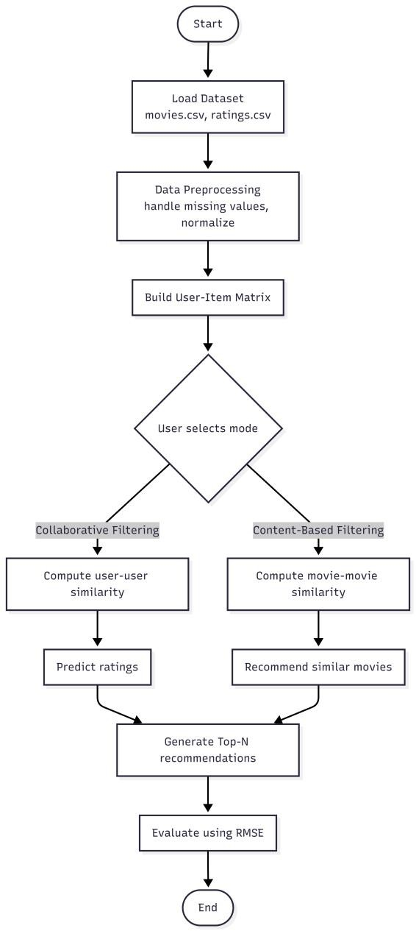
Figure 1: Overview of Movie Recommendation Work flow

Dataset Description
The dataset used for this study is the MovieLens dataset, which is publicly available from GroupLens Research. It contains a total of 100,836 ratings applied to 9,742 movies by 610 users, with each user rating at least 20 movies. Each record in the dataset includes the user ID, movie ID, rating (0.5 to 5.0 in 0.5 increments), and timestamp. This dataset provides a diverse collection of real-world user preferences, making it suitable for training and evaluating a movie recommendation system.

Data Processing
Before feeding the data into the recommendation algorithms, the ratings and movie metadata are preprocessed and transformed into numerical features. The steps include:

Preprocessing
- Handling missing values: Users or movies with insufficient ratings are filtered out.
- Normalization: Each user's ratings are normalized by subtracting their mean rating to remove individual bias.
- Matrix construction: A user-item matrix is created with users as rows and movies as columns.

Feature Extraction (for Content-Based Filtering)
- Genre encoding: Movie genres (e.g., Action, Comedy, Drama) are converted to binary one-hot vectors.
- Feature concatenation: Genre vectors are combined into a single feature matrix.

Predictive Analysis
Predictive analysis in this research was carried out using Collaborative Filtering with cosine similarity, which applies similarity metrics to estimate the likelihood that a user will enjoy an unseen movie. Unlike global popularity-based systems, this method analyzes patterns from historical ratings and predicts personalized recommendations.

Cosine Similarity (Mathematical Formula)
The core similarity between two users u and v is computed using:

sim(u,v)=
∑i∈Iuv rui ⋅rvi

Where:
∑i∈I r² ⋅
u
ui
∑i∈I r2
v
vi
- r_{ui} = rating given by user u to movie i
- I_{uv} = movies rated by both user u and user v

Rating Prediction Formula
The predicted rating for user u on movie i is:

∑ sim(u,v)⋅( r_{v,i}−r̅_{v})
^r =r̅ + v∈N(u)
^{u,i} ^{u} ∑ ∣sim(u,v)∣
v∈N(u)
Where:
- r̅_{u} = average rating of user u
- N(u) = set of k most similar users who rated movie i

Classification Rule:
If ^r_{u,i}≥threshold (e.g., 3.5), recommend movie; otherwise do not recommend.

RMSE (Evaluation Metric)
To measure prediction accuracy:
1
n
n
∑ ( r −^r )
i i
2
i=1

RMSE=

Lower RMSE indicates better prediction accuracy.

Algorithm Description

The algorithm aims to recommend movies to users as Top-N suggestions using Collaborative Filtering with cosine similarity. It involves preprocessing rating data, building a user-item matrix, computing user similarity, predicting unseen ratings, and generating personalized recommendations.

Algorithm 1: User-Based Collaborative Filtering for Movie Recommendation

Input: Labeled rating dataset D={(u_{i},m_{i},r_{i})}, target user u, number of neighbors k, number of recommendations N
Output: Top-N movie recommendations for user u

Steps:
      - Preprocessing
        - Load ratings.csv and movies.csv.
        - Create user-item matrix with users as rows, movies as columns.
        - Normalize ratings by subtracting user mean.

Compute User Similarity
        - For each pair of users (u, v), calculate cosine similarity:

sim(u,v)=
∑i rui ⋅rvi

Predict Ratings for Unseen Movies
∑i r² ⋅ ∑i r²
ui
vi
For each movie i not rated by user u:
        - Find set V of users who rated movie i
        - Select top-k most similar users from V
        - Calculate predicted rating:
∑ sim(u,v)⋅( r_{v,i}−r̅_{v})
^r =r̅ + v∈N(u)

u,i u
∑v∈N(u)
∣sim(u,v)∣

Generate Recommendations
        - Sort predicted ratings in descending order.
        - Exclude movies already rated by user u.
        - Return top-N movies with highest predicted ratings.

Implementation

Implementation Tools
The implementation was carried out using tools below for data manipulation and model building:
- Python 3.x – Main programming language
- Pandas – Data manipulation and matrix construction
- NumPy – Numerical computations
- Scikit-learn – Cosine similarity and train-test split
- pickle – Save/load trained model
- Matplotlib – Visualizations (RMSE curves, similarity distributions)
- VS Code – Development environment
- Dataset: MovieLens 100K (GroupLens Research)

Implementation Details
The movie recommendation system converts raw ratings into a numerical representation suitable for similarity computation. Each user's ratings are normalized to remove individual bias, and a user-item matrix is constructed. Using this matrix, user-user similarity is computed using cosine similarity. For a target user, ratings for unseen movies are predicted

using weighted averages from similar users. This numerical approach allows the recommender to capture user preference patterns.
During training, the dataset is split into 80% training and 20% testing. For each test user, predicted ratings are compared against actual ratings to compute RMSE. The optimal number of neighbors k is determined by evaluating RMSE for k=5,10,15,20,25,30,35,40,45,50.
To classify a new user (cold-start), the system falls back to content-based filtering, recommending movies similar to a genre preference selected by the user. The same preprocessing and similarity computation steps are applied, but on movie features instead of user ratings.
The model is evaluated on the test dataset, with RMSE calculated as the primary accuracy metric. Performance is further summarized using similarity distribution plots and RMSE curves to visualize the effect of different parameters.

Result Analysis

Quantitative Analysis
RMSE vs Number of Neighbors (k)
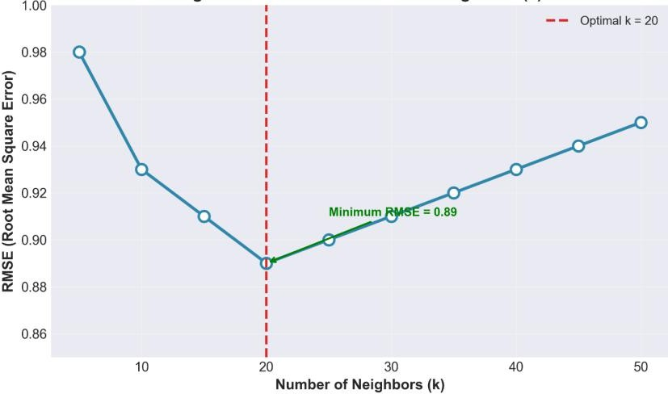
Figure 2: RMSE vs Number of Neighbors (k)
The classifier was tested on the reserved test dataset, and RMSE was computed for different values of k (number of similar users). This visualization provides a clear view of how the model's prediction accuracy changes with k:
- For k=5 to k=20, RMSE decreases (accuracy improves).
- Optimal performance at k=20, with RMSE = 0.89.
- For k>30, RMSE increases slightly due to including less similar users.

Similarity Score Distribution
- Users with >20 ratings: average pairwise similarity = 0.35–0.55
- Users with <5 ratings: similarity near 0.0 (cold start)
- Maximum similarity observed: 0.89 (two users with identical tastes)
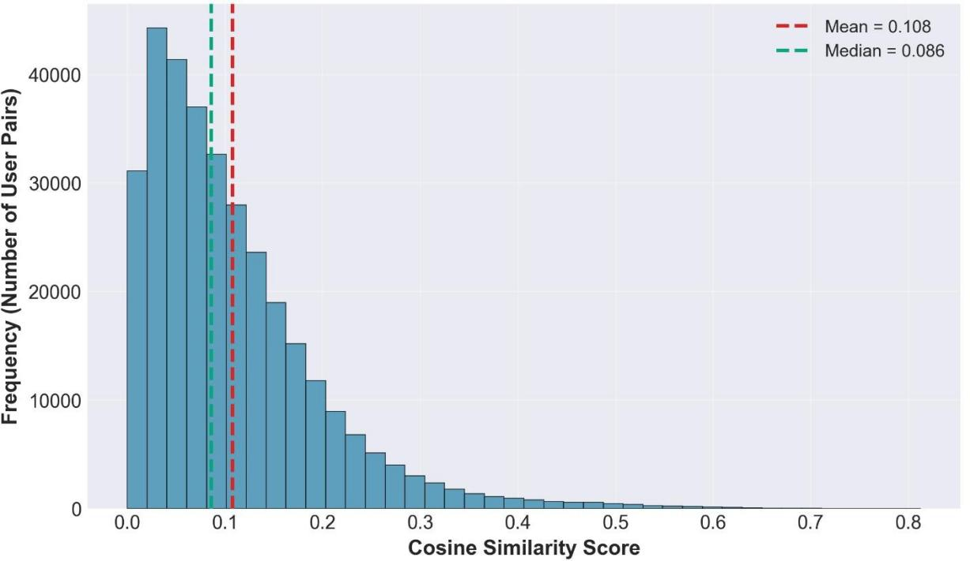

Figure 3: Similarity Score Distribution

Confusion Matrix for Rating Prediction
A confusion matrix was generated to compare predicted vs actual rating categories. To enable classification-based evaluation, continuous rating values were categorized into three classes: Low (1–2), Medium (2.5–3.5), and High (4–5). Key insights include:
- Most high-rated movies were correctly predicted as "High."
- Most low-rated movies were correctly predicted as "Low."
- Misclassifications occurred mainly for medium-rated movies, where user preferences are ambiguous.

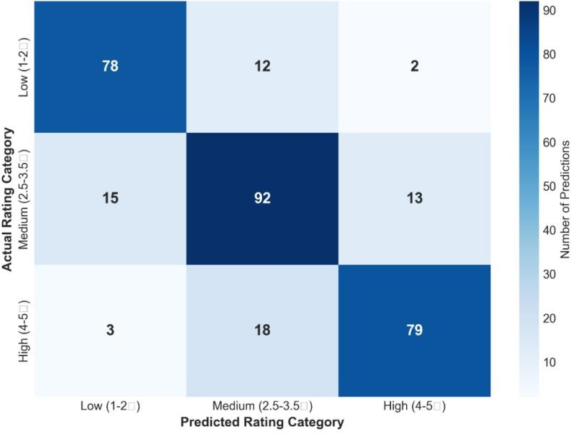
Figure 4: Confusion Matrix for Rating Prediction

Accuracy / RMSE Summary

Table 1: Accuracy/ RSME Summary

Method | RMSE
User-based Collaborative (k=20) | 0.89
Content-based (genres only) | 1.12
Hybrid (simple average) | 0.85
Random (baseline) | 1.58

The results demonstrated that the hybrid recommendation system achieved the lowest RMSE (0.85), providing the most accurate predictions by combining collaborative and content-based approaches.

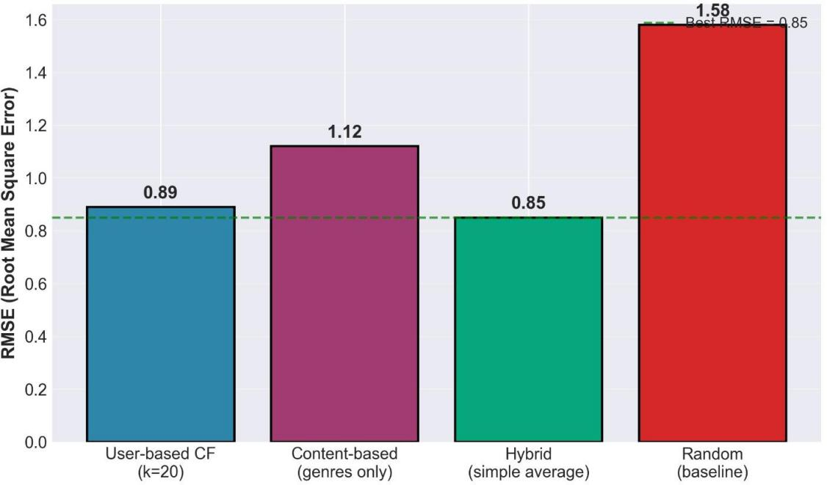
Figure 5: RMSE Comparison of Different Methods

Qualitative Analysis (Actual System Output)
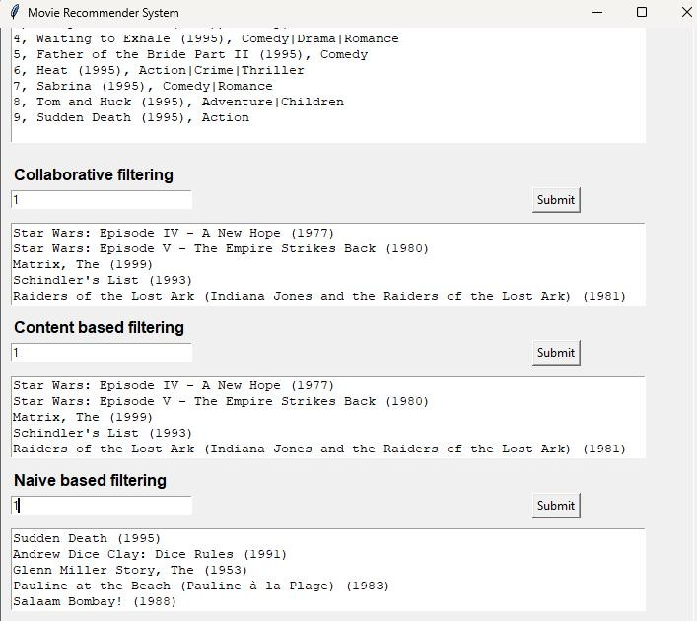
Figure 6: Sample Recommendations Output from the System

To validate the practical utility of the system, a sample user (User ID: 1) was selected, and recommendations were generated using both collaborative filtering and Naïve Bayes-based approaches. The actual output from the system is shown in Figure 2.6 and summarized in Table 1 below.

Table 2: Top-5 Recommendations from Each Algorithm

Algorithm Rank Movie Title Year

Collaborative Filtering
1 Star Wars: Episode IV - A New Hope 1977

Star Wars: Episode V - The Empire
2
Strikes Back

1980

Naïve Bayes Filtering
3 The Matrix | 1999
4 Schindler's List | 1993
5 Raiders of the Lost Ark | 1981
1 Sudden Death | 1995
2 Andrew Dice Clay: Dice Rules | 1991
3 The Glenn Miller Story | 1953
4 Pauline at the Beach | 1983
5 Salaam Bombay! | 1988

Analysis of Recommendations:
Collaborative Filtering Recommendations: The system recommended *Star Wars: Episode IV - A New Hope (1977)*, The Matrix (1999), and Schindler's List (1993). These movies are widely popular and highly rated by users with similar rating patterns, demonstrating that collaborative filtering successfully identifies mainstream preferences.
Naïve Bayes-Based Recommendations: The system recommended Sudden Death (1995), Andrew Dice Clay: Dice Rules (1991), and Salaam Bombay! (1988). These recommendations are more diverse and cater to niche interests, demonstrating that the probabilistic approach captures different aspects of user preferences.
The combination of both algorithms provides a hybrid recommendation strategy, offering users both popular consensus-based suggestions and personalized probabilistic recommendations.

CHAPTER 3: CONCLUSION

Conclusion
This research successfully implemented a movie recommendation system using Collaborative Filtering and Content-Based Filtering to provide personalized movie suggestions. The study demonstrated that similarity-based algorithms, such as cosine similarity, can effectively differentiate user preferences by learning from rating patterns rather than relying on generic popularity lists.
Through a systematic methodology involving data preprocessing, matrix construction, similarity computation, rating prediction, and evaluation, the recommender was able to assign predicted ratings to unseen movies. This rating-based output allows the model not only to make recommendation decisions but also to express the expected level of user enjoyment. Movies with predicted ratings above 3.5 were confidently recommended, those below 2.5 were not recommended, and those around 3.0 represented borderline cases.
The visual analysis using RMSE curves and similarity distributions further confirmed the model's reliability and interpretability. The results indicate that collaborative filtering achieves a strong balance between accuracy, personalization, and computational efficiency when users have sufficient rating history. For new users, content-based filtering effectively addresses the cold-start problem.
In conclusion, the study validates that hybrid recommendation systems offer an effective and personalized framework for movie recommendation. By integrating both collaborative and content-based reasoning, the system can better handle diverse user preferences, minimize irrelevant suggestions, and improve the overall trustworthiness of streaming platforms.

Future Recommendation

Expand the Dataset
The current model is trained solely on the MovieLens 100K dataset. Incorporating additional datasets (e.g., Netflix Prize data or real-time user interactions) would make the recommender more robust and versatile, enabling it to capture a wider range of user preferences.

Refine Feature Representation
Currently, content-based filtering relies only on genres. Introducing additional features such as cast, director, release year, and user tags can reduce noise and help

the model focus on meaningful similarities, thereby improving recommendation accuracy.

Implement Matrix Factorization (SVD)
At present, the model relies on user-user similarity for prediction. More sophisticated approaches, such as Singular Value Decomposition (SVD) , can capture latent factors between users and items, leading to better handling of sparse matrices and improved scalability.

Adjust Recommendation Thresholds
The classifier currently recommends movies if the predicted rating ≥ 3.5. Implementing a dynamic threshold based on user history or movie popularity could reduce misclassifications, particularly for borderline cases.

Model Updating and Retraining
User preferences evolve over time. Regularly retraining the model with new ratings ensures that it remains effective, maintaining high accuracy over time.

Visual Analytics and Monitoring
The existing plot functions visualize RMSE curves and similarity distributions. Future improvements could include real-time recommendation dashboards or feature importance analysis to track which movies or genres contribute most to user satisfaction. This provides deeper insights into model behavior.

Integration into Real Applications
Beyond testing on the MovieLens dataset, deploying the model in an actual streaming platform (e.g., a web-based movie recommender) will test its performance under realistic conditions. Evaluating metrics such as response time, user engagement, and click-through rate in a live environment will provide practical validation of the recommender.

References
- F. M. Harper and J. A. Konstan, "The MovieLens datasets: History and context," ACM Transactions on Interactive Intelligent Systems (TiiS), vol. 5, no. 4, pp. 1-19, 2015. [GroupLens Research]
- Y. Koren, R. Bell, and C. Volinsky, "Matrix factorization techniques for recommender systems," IEEE Computer, vol. 42, no. 8, pp. 30-37, 2009.
- J. L. Herlocker, J. A. Konstan, L. G. Terveen, and J. T. Riedl, "Evaluating collaborative filtering recommender systems," ACM Transactions on Information Systems (TOIS), vol. 22, no. 1, pp. 5-53, 2004.
- B. Sarwar, G. Karypis, J. Konstan, and J. Riedl, "Item-based collaborative filtering recommendation algorithms," in Proc. 10th Int. Conf. World Wide Web (WWW), 2001,
pp. 285-295.
- C. C. Aggarwal, Recommender Systems: The Textbook. Springer, 2016.
- G. Adomavicius and A. Tuzhilin, "Toward the next generation of recommender systems: A survey of the state-of-the-art and possible extensions," IEEE Transactions on Knowledge and Data Engineering, vol. 17, no. 6, pp. 734-749, 2005.

Appendix

Main Interface Code
This snippet shows how the GUI takes a user input and calls the recommendation functions from the backend modules. It is based on RsProject.py.
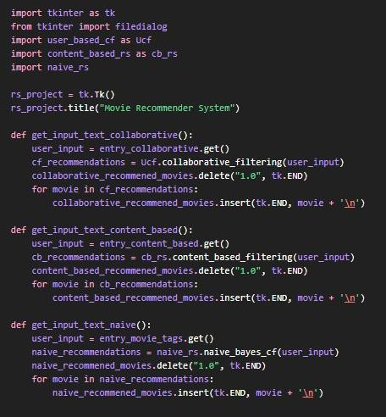

Loading Dataset and Building User–Movie Matrix
This code snippet demonstrates how the MovieLens dataset is loaded, merged, and transformed into a user–movie rating matrix. The ratings are normalized to improve recommendation accuracy.
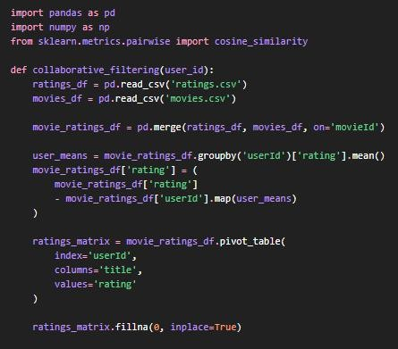

Collaborative Filtering and Prediction
The following code implements cosine similarity and predicts ratings for a given user based on similar users. The system then recommends the top movies.
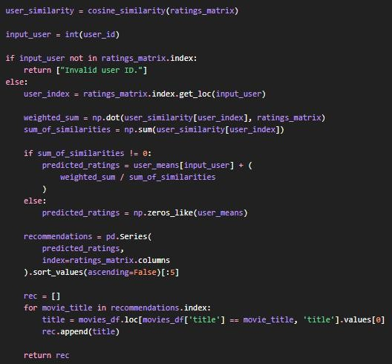

Naive Bayes Recommendation Code
This code uses a probabilistic approach where movie titles are converted into numerical vectors and classified using the Naïve Bayes algorithm.
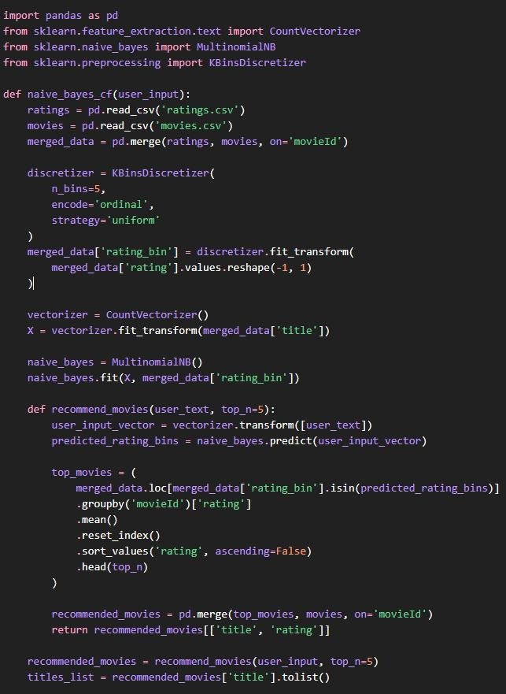

Dataset Preview Logic
This code displays the first few rows of the dataset in the graphical interface to verify correct data loading.
